**HYDROGEN AS AN AIRCRAFT FUEL**

Hydrogen can be used as an aircraft fuel instead of the aviation fuel, jet fuel.

Hydrogen is sustainable fuel if it will produce by nature resources. Hydrogen is a good choice for aircraft fuel, but there are many problems to be faced. Here we have discussed about the aviation fuel, sustainable aviation fuel, hydrogen as fuel and problems to face and some solutions.

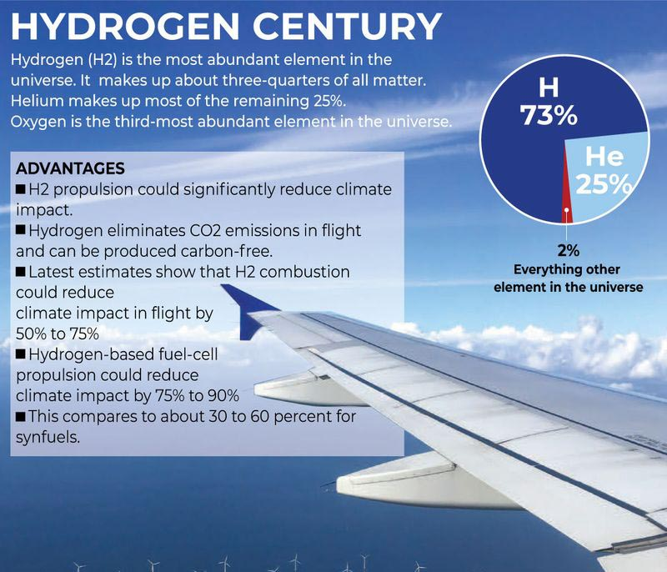

**Aviation Fuel**

Aviation fuels are petroleum-based fuels that power aircraft. They are more stringent heating and road transport fuels, and contain additives to improve or maintain fuel performance and handling.

Here are some types of aviation fuels:

**AVGAS**

Aviation gasoline is used by small private aircraft and older propeller planes. It works well for aircraft with engines that require leaded fuel and a high-octane number.

**Jet A**

A common aviation fuel used in commercial aircraft powered by gas turbines.

**Jet B**

A common alternative to jet fuel and AVGAS, primarily used in civil aviation. Jet B has a low freezing point of -76° C, making it useful in extremely cold areas.

**Jet fuel**

Also known as aviation turbine fuel (ATF), jet fuel is a type of highly refined kerosene. It has a higher energy density than other fuels, allowing for better fuel efficiency and longer flights.

**Biokerosene**

A type of biofuel that replaces aviation kerosene. It is produced from vegetable oils, animal fats, urban waste, and other biofuels.

**Sustainable Aviation Fuels**

Sustainable aviation fuels (SAFs) fall into two categories: carbon neutral drop-in (e.g. synthetic or bio fuels) and non-carbon neutral (e.g., hydrogen). Carbon neutral drop-in results in low (or net-zero) CO2 emissions, while carbon zero (zero-carbon hydrogen) results in no CO2 emissions at all. In the future, photovoltaic (PV) and wind power will enable large-scale production of 'green' hydrogen, significantly reducing carbon emissions and providing an attractive storage option.

**Hydrogen**

A hydrogen-powered aircraft is an airplane that uses hydrogen fuel as a power source. Hydrogen can either be burned in a jet engine or can be used to power a fuel cell to generate electricity to power a propeller.

Hydrogen is classified as "gray" if it is produced using fossil fuels, "blue" if those emissions are captured or offset, and "green" if it is generated by renewable energy with no carbon emissions.

Hydrogen can be used as fuel for aircraft in two ways:

**Fuel cells:** Hydrogen can power electric motors in fuel cells, or be used in adapted gas turbine engines. Hydrogen fuel cells can eliminate CO2 emissions during flight and throughout the energy life cycle if produced from renewable sources.

**Combustion:** Hydrogen can be combusted in adapted gas turbine engines

Hydrogen is likely to be an attractive option for heavy transport, where lower energy density, high upfront costs and slow recharging of batteries are major drawbacks. Hydrogen powered air transport has the potential to reduce climate impact. However, due to its challenging fluid properties and the impact on the aircraft system currently optimized for conventional fuel, high research efforts are needed to bring this technology to the market.

**Challenges**

However, to develop hydrogen-powered commercial aircraft, several technological challenges need to be overcome before its full potential can be exploited. Among these topics, some elements are still at a very low maturity level and will need significant development, maturation and demonstration in order to be ready for integration into future aircraft. One key aspect in which aviation will require a highly specific approach is the fact that hydrogen’s energy density, while very high with respect to mass and as such has a promising potential for flight, is very low with respect to its volume when in gaseous form. For large commercial air transport applications, it is therefore widely expected that only liquid hydrogen systems will prove viable. Liquefying and storing ‘LH2’ presents unique challenges as the temperature of -253C needs to be maintained ‘in the tank’. The resulting effect on tanks, fuel/distribution systems, refueling and on the overall system design, reliability and safety present major research and development challenges. In parallel to the efforts needed to develop the necessary on-board technologies, the availability of hydrogen, its distribution and the necessary recharging/refueling infrastructure, together with renewable production, will be key for the overall success of this approach.

**Hydrogen-powered aircraft face several challenges, including:**

**Low volumetric density**

Hydrogen is much lighter than jet fuel, so it has a lower volumetric density. This means that hydrogen-powered aircraft need four to five times the volume of conventional fuel to carry the same amount of energy.

**Storage**

Hydrogen is very low density at room temperature, so it requires large storage volumes and heavy tanks.

**Safety**

Hydrogen is highly flammable and explosive. As a gas, it's stored under high pressure, which could injure nearby personnel. As a cryogen, it could cause injuries like frostbite.

**Transportation**

Hydrogen is difficult to transport from one place to another.

**Cost**

Hydrogen can be generated by the hydrolysis of water, but it's a very expensive process.

**Aircraft Design**

As hydrogen has low volumetric density, it will take more volume for the same weight as of jet fuel, which effects on the size of the fuel tank. As the size of the tank increases, the total weight of the aircraft also increases.

This affects the design of the aircraft. So, we have to think about the design which will be suitable for carrying required amount hydrogen to cover the desired distance. Or to design a fuel tank that will not affects the weight of the aircraft and also carry required hydrogen.

**ZEROe by AIRBUS-**

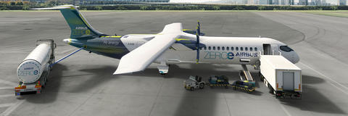

**ZEROe**

Towards the world’s first hydrogen-powered commercial aircraft.

Airbus’ ambition is to bring to market the world’s first hydrogen-powered commercial aircraft by 2035

**Hydrogen propulsion to power future aircraft**

All four ZEROe concepts are powered by hydrogen.

In the case of hydrogen combustion, gas turbines with modified fuel injectors and fuel systems are powered with hydrogen in a similar manner to how aircraft are powered today.

A second method, hydrogen fuel cells, creates electrical energy which in turn powers electric motors that turn a propeller or fan. This is a fully electric propulsion system, quite different to the propulsion system on aircraft currently in service.

These technologies are complementary, and the benefits are additive.

https://www.airbus.com/en/innovation/low-carbon-aviation/hydrogen/zeroe